Documentation of se-assignment1

Windows 11 installation

Using Bootable USB Drive

Insert the bootable USB drive into your PC.

Restart your PC and enter the BIOS/UEFI settings (usually by pressing a key like F2, F12, Delete, or Esc during startup).

Set the USB drive as the primary boot device.

Save the changes and exit BIOS/UEFI.

Your PC will boot from the USB drive, starting the Windows 11 installation process.

Follow the on-screen instructions to complete the installation.

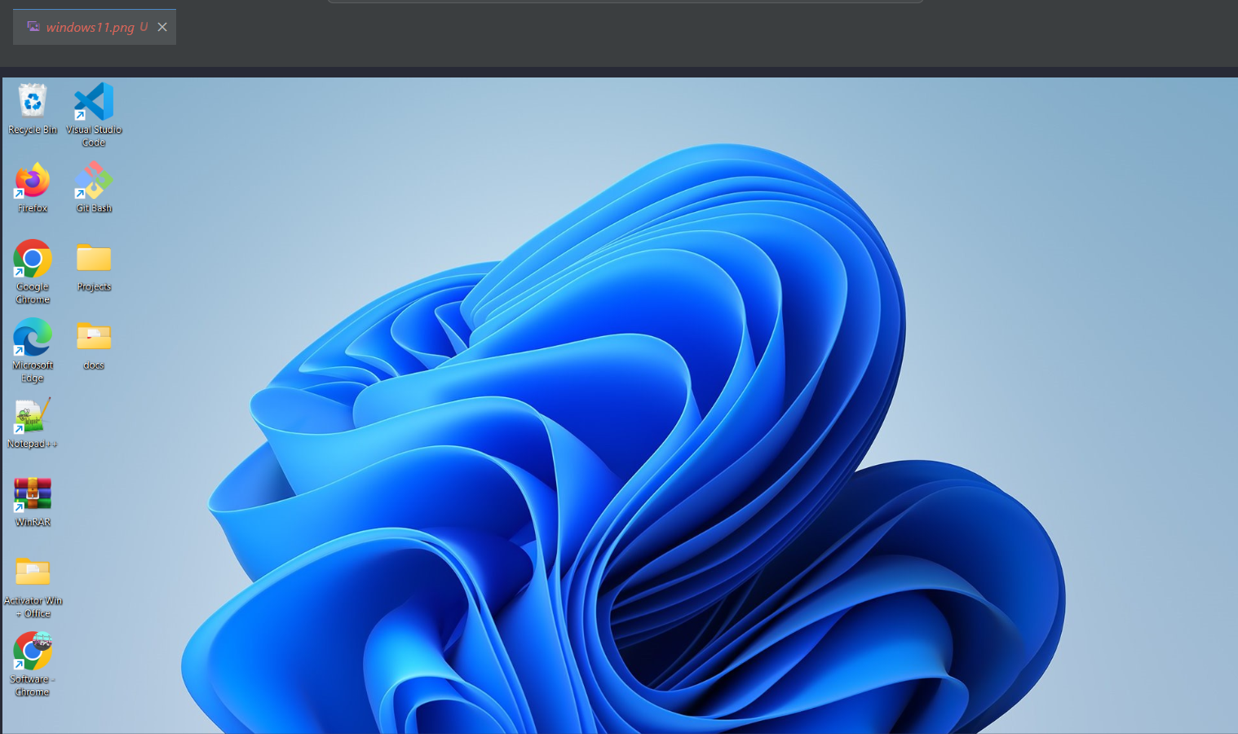

Visual Studio code installation

Visit the Visual Studio website and click on "Download Visual Studio."

Run the downloaded installer.

Click the "Install" button to start the installation process.

Once the installation is complete, launch Visual Studio.



Github installation

On Windows:

Download the Git installer from the official Git website.

Run the installer and follow the prompts. Use the default settings unless you have specific requirements.

Configure Git

Open your terminal or command prompt and run the following commands to set up your Git username and email. Replace "Your Name" and "your.email@example.com" with your actual name and email address.

git config --global user.name "Your Name"

git config --global user.email "your.email@example.com"

Create a GitHub Account

Go to GitHub.

Click on "Sign up" and follow the instructions to create a new account.

Initialize a Git Repository

Create a new directory for your project if you don't have one already.

mkdir my-project

cd my-project

Initialize a Git repository in your project directory

git init

Make Your First Commit

Create a new file or add existing files to your project. For example, create a README.md file

echo "# My Project" > README.md

Add the file(s) to the staging area

git add .

Commit the files to the repository

git commit -m "first commit"

Push to GitHub

On GitHub, create a new repository

Click the "+" icon in the top right corner and select "New repository".

Name your repository and click "Create repository".

Link your local repository to the GitHub repository. Replace your-username and your-repo-name with your GitHub username and the name of your repository:

git remote add origin https://github.com/your-username/your-repo-name.git

Push your local commits to GitHub either to main or create a new branch by using the git checkout -b "name"

git push -u origin main

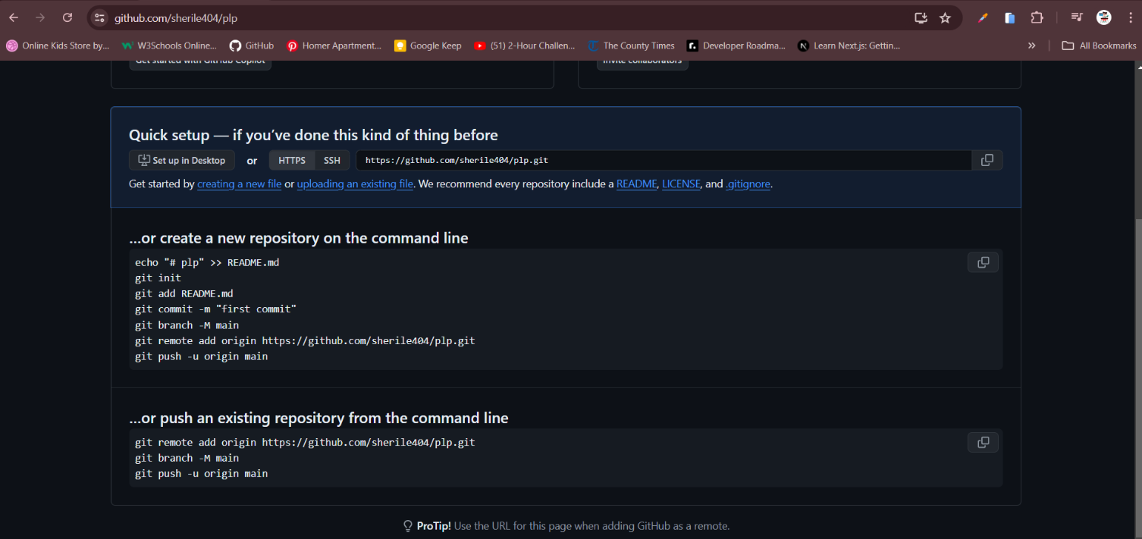

Python Installation

Run the installer you downloaded. Make sure to check the box that says "Add Python to PATH" before clicking "Install Now." This ensures you can run Python from the command line.

Follow the on-screen instructions to complete the installation.

Verify Installation

Open a command prompt or terminal and type the following command to verify that Python is installed correctly

python --version

Install pip (Python's Package Installer)

pip is included by default in Python 3.4 and later. Verify pip installation

pip --version

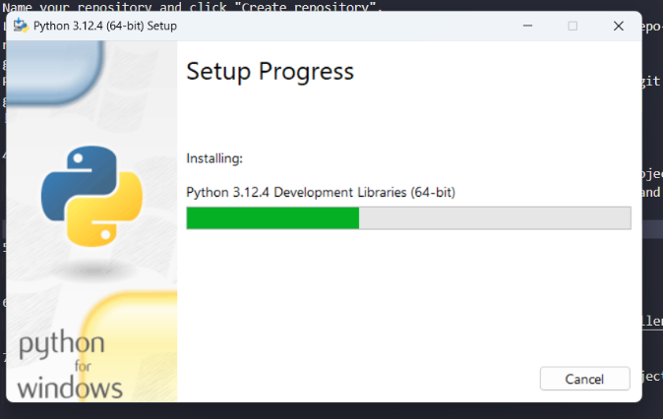

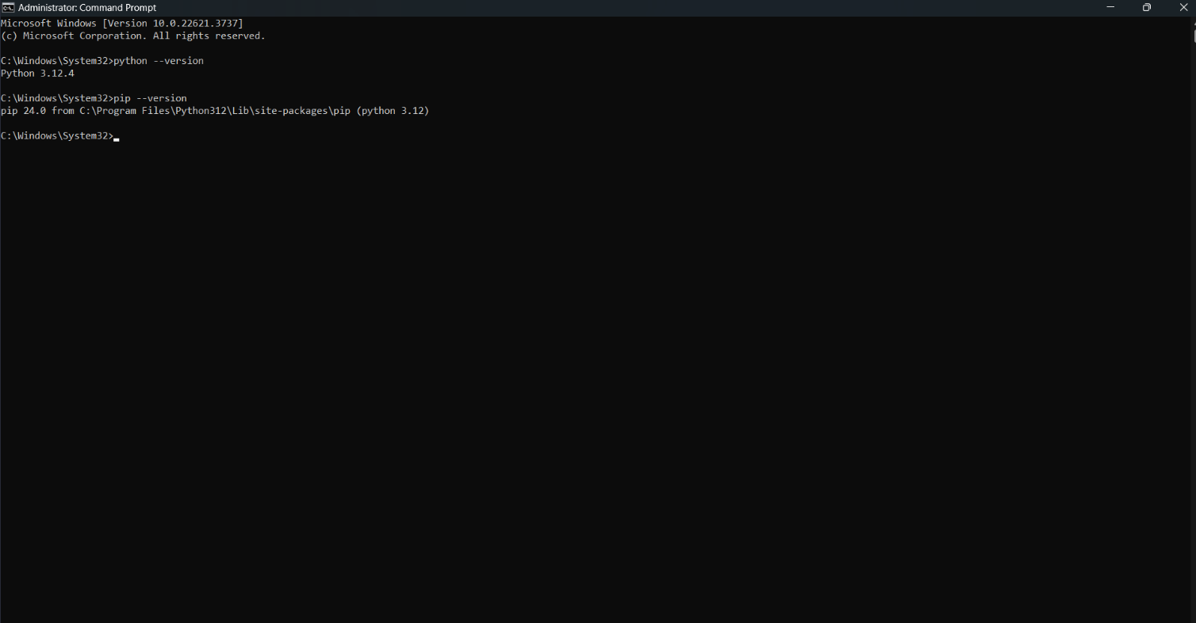

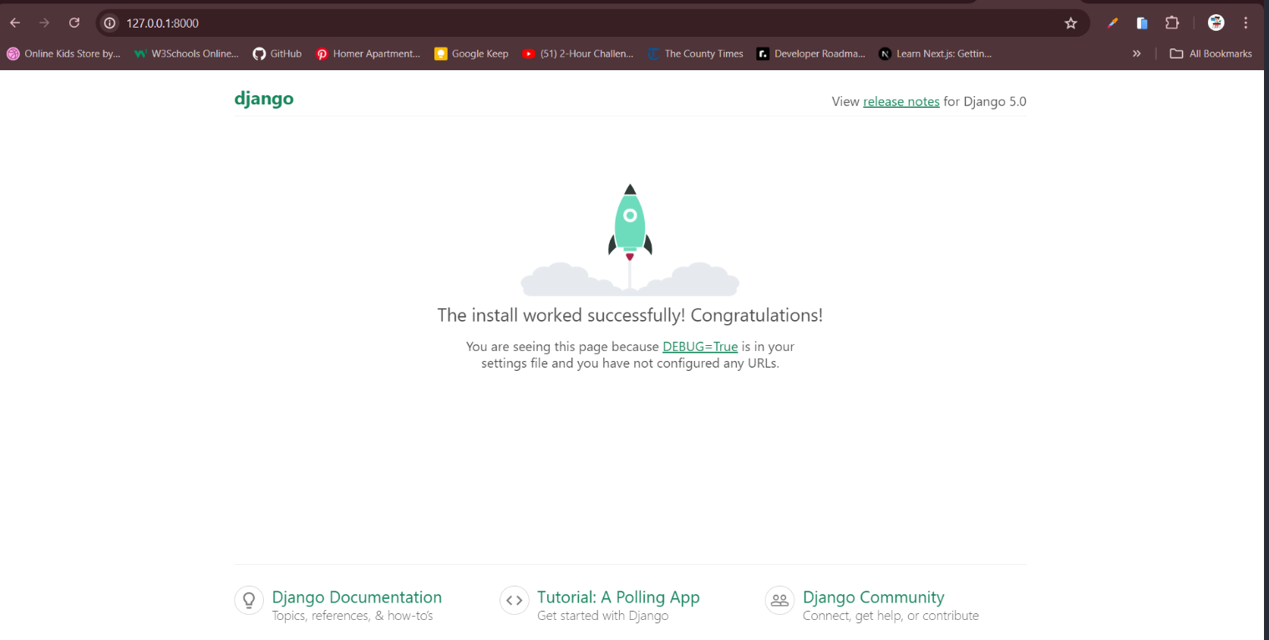

Pip installation

pip is included by default with Python installations starting from Python 3.4. To check if pip is installed, open Command Prompt and type:

pip --version

If pip is not installed, you can manually install it using the following commands:

python -m ensurepip --upgrade

After installing, you can verify that pip is correctly installed by typing:

pip --version

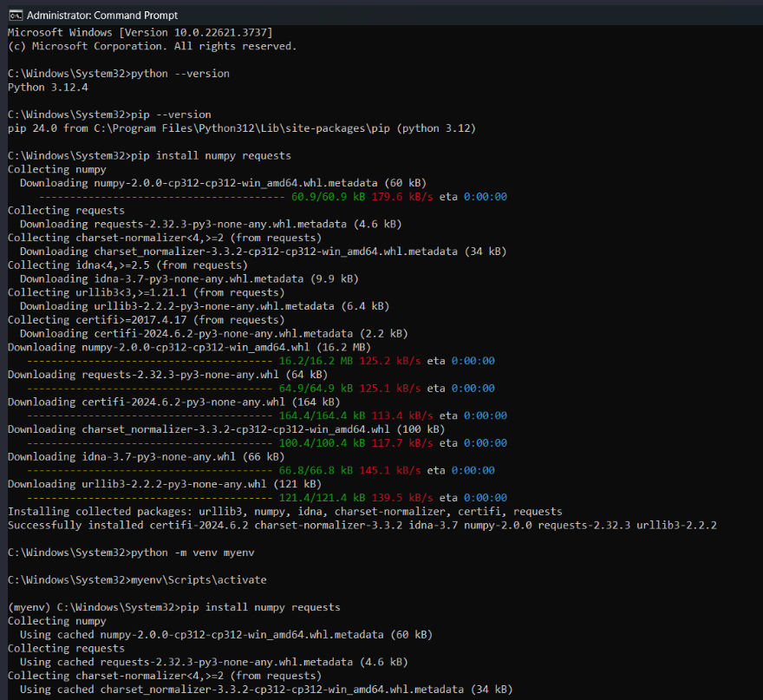

To download and install MySQL on my Windows11, I followed these steps:

Step 1: Download MySQL Installer

Go to the MySQL Installer download page https://dev.mysql.com/downloads/file/?id=528489.

Click on the "Download" button next to your chosen installer.

You may be prompted to log in or sign up for a free Oracle Web account, but you can also click on "No thanks, just start my download" to proceed without signing up.

Step 2: Run the MySQL Installer

Once the download is complete, locate the installer file (e.g., mysql-installer-community-5.7.X.msi) and double-click to run it.

If prompted by User Account Control, click "Yes" to allow the installer to make changes to your device.

Step 3: Choose the Installation Type

The MySQL Installer will launch, and you will be presented with several setup types:

Developer Default: Installs MySQL server and other MySQL products for development.

Server only: Installs only the MySQL server.

Client only: Installs MySQL client programs and libraries.

Full: Installs all MySQL products.

Custom: Allows you to choose which products to install.

Select the setup type that best fits your needs. For most users, "Developer Default" is a good choice. Click "Next".

Step 4: Check Requirements

The installer will check for any required software or updates. If any requirements are missing, the installer will prompt you to install them.

Click "Execute" to install any required software and then click "Next" when all requirements are met.

Step 5: Installation

The installer will display a list of products to be installed. Review the list and click "Execute" to begin the installation.

The installation process may take some time. Once complete, click "Next".

Step 6: Configuration

After installation, you will be prompted to configure the MySQL server. Click "Next" to proceed.

Config Type: Choose the configuration type that best suits your needs (e.g., "Development Machine", "Server Machine", or "Dedicated Machine").

Connectivity: Set the desired port for MySQL (default is 3306) and configure firewall settings if necessary. Click "Next".

Authentication Method: Choose the authentication method (e.g., "Use Strong Password Encryption" or "Legacy Authentication Method"). Click "Next".

Accounts and Roles: Set the root password and create any additional user accounts if needed. Click "Next".

Windows Service: Choose whether to run MySQL as a Windows service and name the service. Optionally, you can set the service to start automatically. Click "Next".

Apply Configuration: Click "Execute" to apply the configuration settings. Once completed, click "Finish".

Step 7: Complete the Installation

The MySQL Installer will display a summary of the installation and configuration process. Click "Finish" to exit the installer.

Step 8: Verify the Installation

Open a Command Prompt.

Type mysql -u root -p and press Enter.

When prompted, enter the root password you set during the configuration.

If the MySQL prompt appears (mysql>), the installation was successful.

